CURRICULUM VITAE
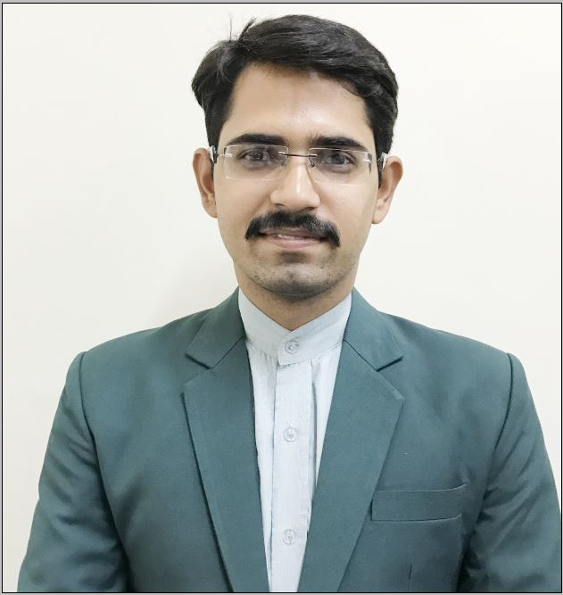

Bajrang Lal

VPO Bassai
Distt. Mahendergarh
Haryana

Contact No.+91-9467863514

Email: bajrang.ravi@gmail.com

I am a fast learner, sincere, hardworking and capable of representing myself from concept to completion, sensitive to deadline, good analytical and communication skills. Take initiatives and work in a planned manner to achieve the defined targets.

Career Objective

Intend to build a career with leading Institute of hi-tech environment with committed & dedicated people, which will help me to explore myself fully and realize my potential. Willing to work as a key player in challenging & creative environment.

Qualification

Qualification | Discipline / Specialization | Board/ University | Year of Passing | Marks% | Class
MHMCT | Tourism & Hotel Management | Central University of Haryana | 2017 | 74 | 1st
B.Sc. | PCM | SRU Rajasthan | 2013 | 64.10 | 1st
Intermediate | PCM | BSEH Bhiwani | 2009 | 72.40 | 1st
Matriculation | Science | BSEH Bhiwani | 2007 | 86.60 | 1st

Computer Skills

- Knowledge of Computer.
- MS. Word, PowerPoint, Excel, Publisher etc.
- Adobe Photoshop, PageMaker.

Professional Skill Development

- Industrial visit to hotel The Fern , Jaipur
- Industrial visit to Chowki Dhani Resort, Jaipur.
- Participated in Towel Art Workshop organized at C.U.H.

Achievements
- Securing 100% marks in Mathematic subject in Middle Board.
- “Best Creator” award in NSS from Central University of Haryana.
- Certificate of Appreciation from DTHM CUH for Theme Teej Festival.
Extra-Curricular Activities

- National Service Scheme & Youth Red Cross.
- Worked at National Digital Literacy Mission under Government of India.

Strengths:

      - Ability to work with confidence.
      - Dedication to work.
      - Result oriented & creative teaching and good solving capability.
      - Continuous improvement & never leave my work in between.

Hobbies:

- Listening Music
- Watching Cricket
- Internet Surfing
- Creating on Adobe Photoshop

Personal details

Name : Bajrang Lal
Date of birth : 10th March, 1992
Father’s Name : Sh. Mange Ram
Nationality : Indian
Passport Number : P3855130
Sex : Male
Marital status : Unmarried
Languages Known : English, Hindi & Sign

Date:
Place:
(Bajrang Lal)

