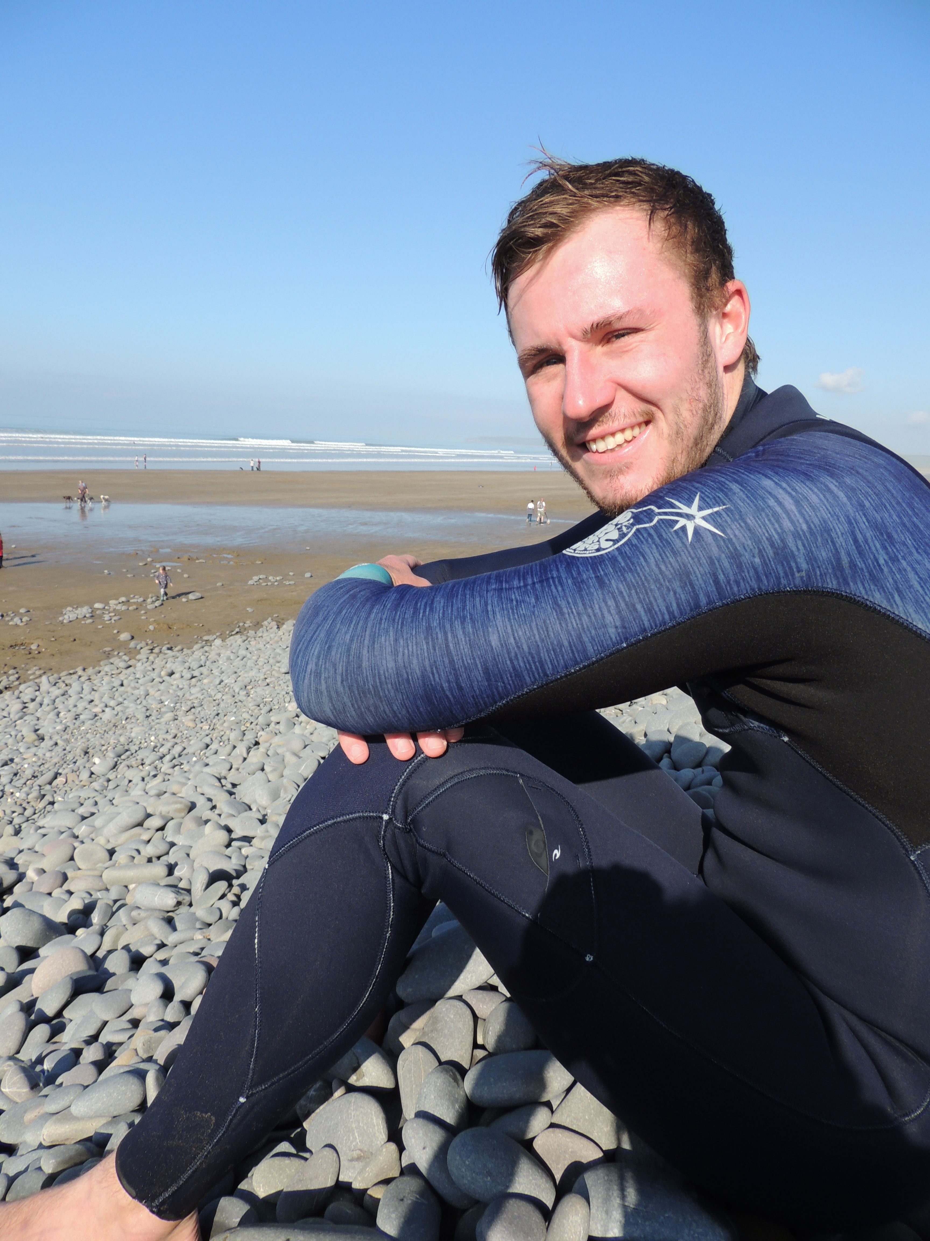

Tom Moores
White British
DOB:26/06/1995
38 Lagoon View, Yelland, Barnstaple,
Devon, United Kingdom
EX31 3LD
07940063520
Moorezy@hotmail.co.uk

Objective:
I have a significant enthusiasm for the outdoors and put every effort into anything that is involved amongst the environment of sport. I have grown up as an adventurous individual as a result have build a great sum of experience across quite a range of sports. After completing my degree three years ago, I knew that I wanted to be an outdoor education instructor. I am a very outgoing person who loves a challenge. I love all aspects of being an activity instructor. I regard myself as having a great rapport with all the children that I teach. No two children are the same and I feel that I can adapt to make their visit fun and very enjoyable. I love helping children overcome their fears with an activity and I find it extremely rewarding. As an instructor, I find I have the ability to identify and meet a person’s needs from the start of a session through till end. I have become very passionate about teaching children and adults and giving them the experiences in outdoor sports such as kayaking, climbing, mountain biking etc. I am very motivated and when I am leading groups, I find it easy to keep members of the group enthusiastic and engaged throughout the sessions. It’s a subconscious ability of mine which comes from my passion. I am extremely hard working and have a vast amount of experience within the outdoor environment.
I have very good interpersonal skills and a sense of humour. I feel this is a necessity for this role. I am so very fortunate to enjoy every day as an instructor as I love all outdoor sports and I am ever keener on building my levels of experience within the outdoors and learn more skills. I have just received my 23 Month Working Visa for New Zealand and I am now actively looking for employment.

Experience in Outdoor Sports
From a young age, I have always been outside participating in various kinds of sport. The first sport I was interested in was mountain biking. I built my ability up to be able to go to bike parks where I could run black runs with ease. As time went on, I became more interested in water sports such as surfing, kayaking, canoeing and wakeboarding, but still carried on with MTB. I earned instructor level qualifications for kayaking and canoeing and as soon as I earned them, I immediately wanted to assist other people in developing their skills. I joined a club and after a few sessions I started helping newcomers to kayaking with teaching them base skills. Whilst at University, I got fully captivated with climbing and abseiling. With my course, we went on several trips weekly where we would do an activity; climbing was a main one, along with Kayaking. These trips taught me all the necessary skills you need to carry out solo participation, which really helped me develop and gain my qualifications. Once I finished the course, I bought my own equipment and made the most of it. Shortly after I finished university, I secured my first activity instructor post which is where my true development started. The job role taught far more important skills in all the sports I currently participated in. I have recently left this employment with a high standard of knowledge towards a vast amount of activities and I am now seeking the chance to broaden my skill set in a different environment.

Coaching/ Teaching/ Instructing Roles
I have been an activity instructor and group leader for a UK based company called PGL for the last 3 years and within this time I have delivered a range of 24 different activities. The main activity I instructed was Surfing as the staff team needed people of high capacity to be a coach. Alongside this I taught numerous rope activities including Zipwire, High Ropes, Climbing and Abseiling. Other activities that I delivered included Mountain Biking, Quad Biking, Archery, Fencing, Bush Craft, Rifle Shooting and Problem Solving. At PGL, my role had two sides, an Instructor role and a Group leader role. The GL was there as a guest support whilst the groups weren’t on activities. Their duties included taking the group through all meal times, organising events for their free time and being the first point of contact for any issues that the groups had. So, through my time at PGL, I built confidence in both the Instructor role and a guest care role too.

Outside of PGL I am an active member of my local kayak and canoe club where I often get chances to instruct newcomers to the sport. The club host pool session on a fortnightly basis in which I assist people in developing their base skills or helping people learn how to roll. This is all voluntary and my help was greatly appreciated as I pushed people towards getting their official kayaking qualifications.

Summary of Qualifications:

Duke of Edinburgh Silver Award
BCU Level 2 Kayak and Canoe
UKCC Level 1 Paddle Sport Coach Training and Assessment
FSRT (Foundation Safety and Rescue Training)
Full UK Car Drivers License
British Fencing Core Coach Award
Mountain Bike Leader Award Level 1
Safety Training level 2 Award in emergency First Aid at Work.
National Water Safety Management Programme Level 3

Outdoor Instructor Employment History:
Job Title
Activity Instructor/Group Leader
PGL, Torrington, Devon, UK.
Dates of Employment: 21st Feb 2016/18th Oct 2018.

Education:
High School Name,
Kingsley School, Bideford, Devon, UK
2006-2013

University Name,
Exeter College, Exeter, Devon, UK
2013-2015

Qualification type (UK Based Qualifications)

Foundation Degree in Applied Outdoor Adventure. (Further Education/degree)
A Levels in Business Studies and Physical Education (Higher Education)
8 GCSE’s of grade C or higher, including Maths and English.

Activities:

I regularly surf as I live close to the coast where we have some great beaches. As I belong to the kayak and canoe club, I also go on various river trips around the area which are usually white water but are sometimes flat water. I also thoroughly enjoy Mountain Biking, Climbing, and Snowboarding. All of which I have my own personal gear I use.

Languages:
English.

