CURRICULUM VITAE

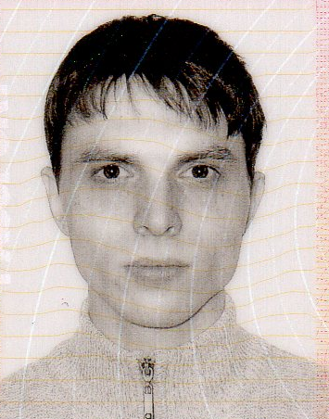

INSERT

PHOTO

HERE

Iurii Teterevkov

Mobile | 021 086 686 12;
Email | ikiro@inbox.ru teterevkov@yahoo.com

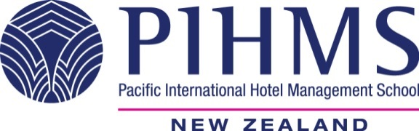

PERSONAL STATEMENT

I travelled to many different countries, and have the ability to deal with people from different countries. It takes some time for me to adapt to new people and working environment, but I like working with people I know. I believe that I am an honest and broadminded person. I am also very thorough and hardworking, and think that if I am doing something, I should do it as good, as possible. I have recently graduated from Pacific International Hotel Management School with diploma, and currently continue my studies for bachelor degree in hotel management, which I will be getting in December 2017.

SKILLS and COMPETENCIES
- Drivers Licence: New Zealand and Russian
- Can speak English and Russian
- Beginner level Japanese language
- Diploma in Tourism and Hospitality Management

WORK EXPERIENCE

 | PIHMS
Start Date: | February 2014
Finish Date: | July 2014
Position Title: | Food and Beverage trainee
Position Description: | Trained in all aspects of food service and food production in a fully functioning hotel restaurant environment with focus on customer service and soft skills as well as the practical competencies.

 | Scenic Hotel Bay of Islands
Start Date: | September 2014
Finish Date: | February 2015
Position Title: | Restaurant worker
Position Description: | Working in hotel restaurant environment servicing customers both during normal working days and during conference functions and events.

 | PIHMS
Start Date: | May 2015
Finish Date: | November 2015
Position Title: | Front office and housekeeping trainee
Position Description: | Trained in all aspects of front office and housekeeping operations in a fully functioning hotel environment with focus on customer service and soft skills as well as the practical competencies.

 | Picton Yacht Club Hotel
Start Date: | November 2015
Finish Date: | April 2016
Position Title: | General Sales Assistant
Position Description: | Working in hotel environment, including front office, restaurant and housekeeping, servicing customers both during normal working days and during conference functions and events.
EDUCATION
DUCATION
2017 3rd Year Student in Diploma of Hotel Management
PIHMS
Subjects: Innovation Management 3
Applied Hospitality 3
Business Evaluation 3
Management 3
Marketing 3
Research 3
Tourism 3

2015 2nd Year Student in Diploma of Hotel Management
PIHMS
Subjects: Front Office Operations
Front Office Management
Housekeeping Operations
Applied Hospitality 2
Business Evaluation 2
Management 2
Marketing 2
Research 2
Tourism 2

2014 1st Year Student in Diploma of Hotel Management
PIHMS
Subjects: Food Production Operations
Food Service Management
Food Service Operations
Applied Hospitality 1
Business Evaluation
Communications
Management
Computing
Marketing
Research
Tourism

2008 – 2013 Far Eastern State University of Humanities
Subjects: Japanese Language
English Language
Physical Education
History
Philosophy
Sociology

OTHER ACHIEVEMENTS
- Undergraduate education in Japanese language provided by Far Eastern State University of Humanities, from 1.09.2008 to 30.06.2013.
- Successful completion of Annual International Exchange Program at Niigata University of Management in February 2013

INTERESTS

- Translation
- Writing
- Learning new languages

REFEREES

Agnes Erwin Conference Coordinator
Scenic Hotel Bay of Islands
Ph +64 9 402 7826
conference.bayofislands@scenichotels.co.nz

Joanne Pickering Assistant General Manager
Picton Yacht Club Hotel
Ph +(64) 3 573 7002
sales@pictonyachtclubhotel.com

